**INTELLIGENT AGENT: TEACH SUBTRACTION TO A CHILD**

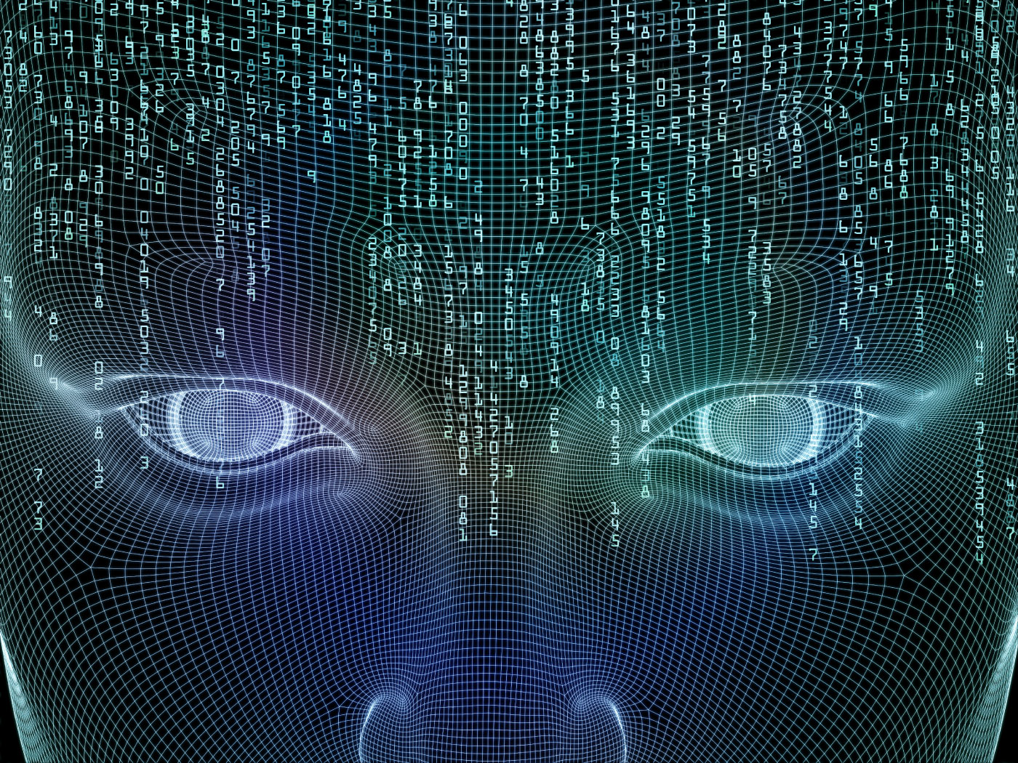

**CONTENTS**

|  |  |  |
| --- | --- | --- |
| **S.No.** | **Topic** | **Page No.** |
| **1.** | **Acknowledgement** | **3** |
| **2.** | **Introduction** | **4** |
| **3.** | **Methodology Used** | **5** |
| **4.** | **Features** | **6** |
| **5.** | **Technologies Used** | **13** |
| **6.** | **Conclusion** | **14** |

**ACKNOWLEDGEMENT**

I would like to express my deep sense of gratitude to my teacher, Professor Shailendra Singh to organize and give me such an innovative project. He has given me appropriate examples and knowledge in order to complete my project. He also provided me innumerous practical examples of how to incorporate Artificial Intelligence in even the simplest of projects. This project has been brought completely up to date in the light of helping hands offered to me by him. I would also like to thank my parents for their time to time interaction, assistance and advice. I would also like to thank my fellow classmates and friends who were willing to share information and give their precious inputs and a lot of new ideas which helped me to improve upon my project**.**

**INTRODUCTION**

**Artificial intelligence** (**AI**) is [intelligence](https://en.wikipedia.org/wiki/Intelligence) exhibited by [machines](https://en.wikipedia.org/wiki/Machine). In [computer science](https://en.wikipedia.org/wiki/Computer_science), an ideal "intelligent" machine is a flexible [rational agent](https://en.wikipedia.org/wiki/Rational_agent) that perceives its environment and takes actions that maximize its chance of success at some goal. Colloquially, the term "artificial intelligence" is applied when a machine mimics "cognitive" functions that humans associate with other [human minds](https://en.wikipedia.org/wiki/Human_mind), such as "learning" and "problem solving". As machines become increasingly capable, facilities once thought to require intelligence are removed from the definition. For example, [optical character recognition](https://en.wikipedia.org/wiki/Optical_character_recognition) is no longer perceived as an exemplar of "artificial intelligence", having become a routine technology. Capabilities currently classified as AI include successfully [understanding human speech](https://en.wikipedia.org/wiki/Natural_language_processing), competing at a high level in strategic game systems (such as [Chess](https://en.wikipedia.org/wiki/Chess) and [Go](https://en.wikipedia.org/wiki/Go_%28game%29)), [self-driving cars](https://en.wikipedia.org/wiki/Self-driving_cars), and interpreting complex data. AI is also considered a danger to humanity if it progresses unabatedly. AI research is divided into subfields that focus on specific [problems](https://en.wikipedia.org/wiki/Artificial_intelligence#Goals) or on specific [approaches](https://en.wikipedia.org/wiki/Artificial_intelligence#Approaches) or on the use of a particular [tool](https://en.wikipedia.org/wiki/Artificial_intelligence#Tools) or towards satisfying particular [applications](https://en.wikipedia.org/wiki/Artificial_intelligence#Applications).

The central problems (or goals) of AI research include [reasoning](https://en.wikipedia.org/wiki/Reasoning), [knowledge](https://en.wikipedia.org/wiki/Knowledge), [planning](https://en.wikipedia.org/wiki/Automated_planning_and_scheduling), [learning](https://en.wikipedia.org/wiki/Learning), [natural language processing](https://en.wikipedia.org/wiki/Natural_language_processing) (communication), [perception](https://en.wikipedia.org/wiki/Perception) and the ability to move and manipulate objects. That is what I have tried to improve in my project.

**METHODOLOGY USED**

**Objective:-** To make an artificially intelligent agent which can teach a child Subtraction.

I built an online artificially intelligent agent which teaches a child subtraction. It takes the input of the child’s name and the child’s age and accordingly teaches the child with various levels of teaching. The child’s learning process is made interactive using various chapters and examples and short exercises. All the chapters include pictures and illustrations in order to increase the child’s interest and increase interaction.

The child is then given the task of clearing a practice exercise which is not only his/her evaluation but also a verification of whether the child is able to learn subtraction or not. The child is then provided a feedback on his/her performance. The feedback includes whether he/she should revisit subtraction and if yes, what is that the child should revise or whether he is pretty good at subtraction and is ready for any subtraction exam!

**FEATURES**

**1) START OF THE APPLICATION: -** The child is asked for his or her name and age on the start page of the application.

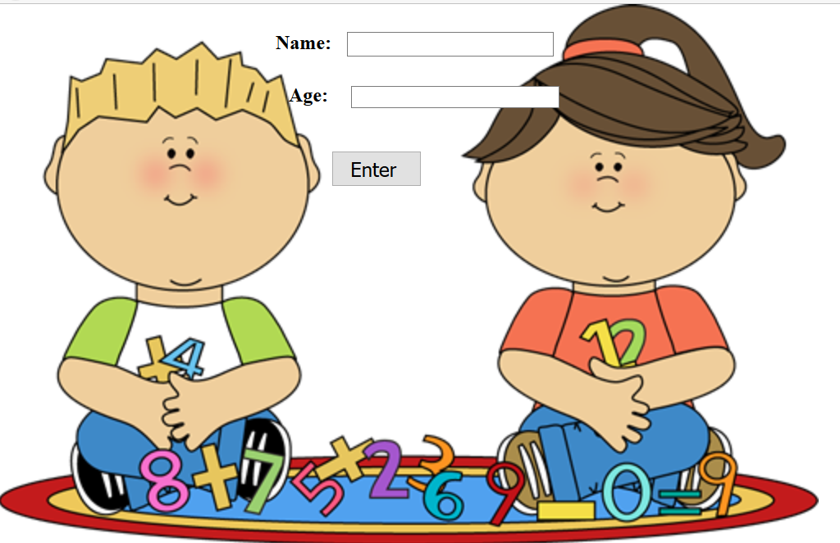

**2) AGE CHECK:** - An age checking algorithm is applied in the backend which checks whether the age inputted by the child is correct or not so that he or she can be transported to the appropriate page accordingly. If the user enters a negative age or a string value, he/she is informed that the age is wrong and should be inputted again. If the user enters an age that is greater than 12 then he/she is informed that the lesson is too naïve for him/her. After the correct user input the child is transported to the main page which contains all the lessons and practice exercise.

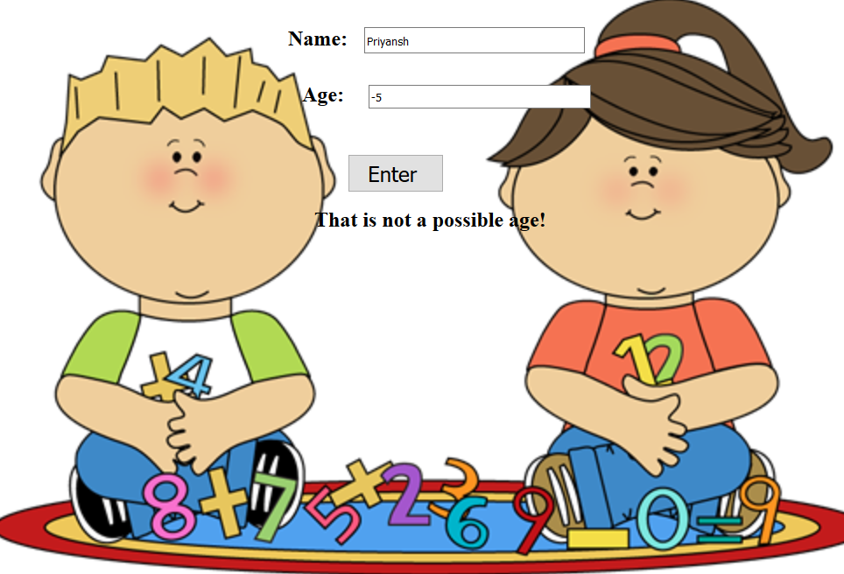

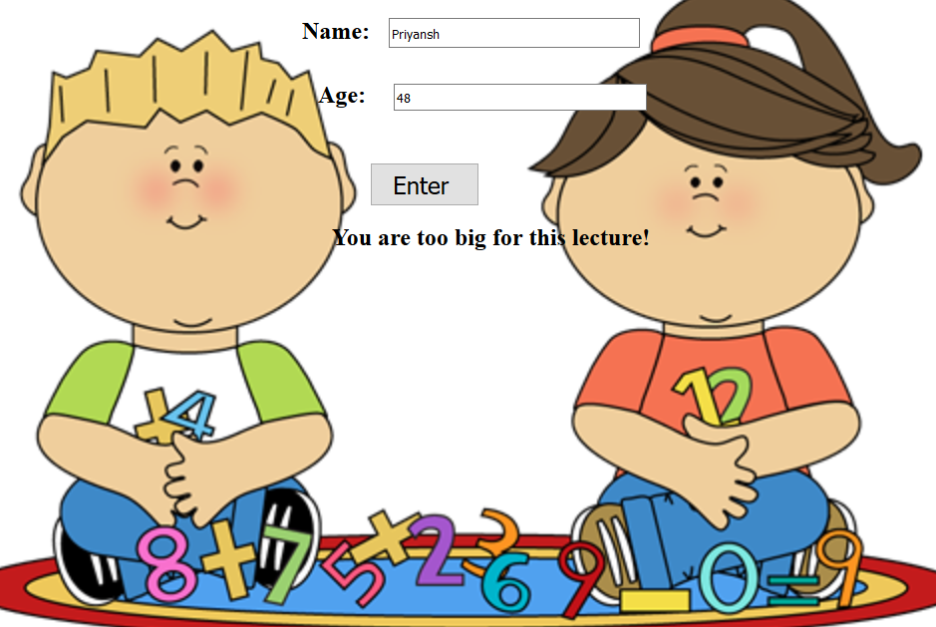

**3) MAIN PAGE:** - The child is transported to the main page now where he can find the lessons corresponding to his knowledge levels. 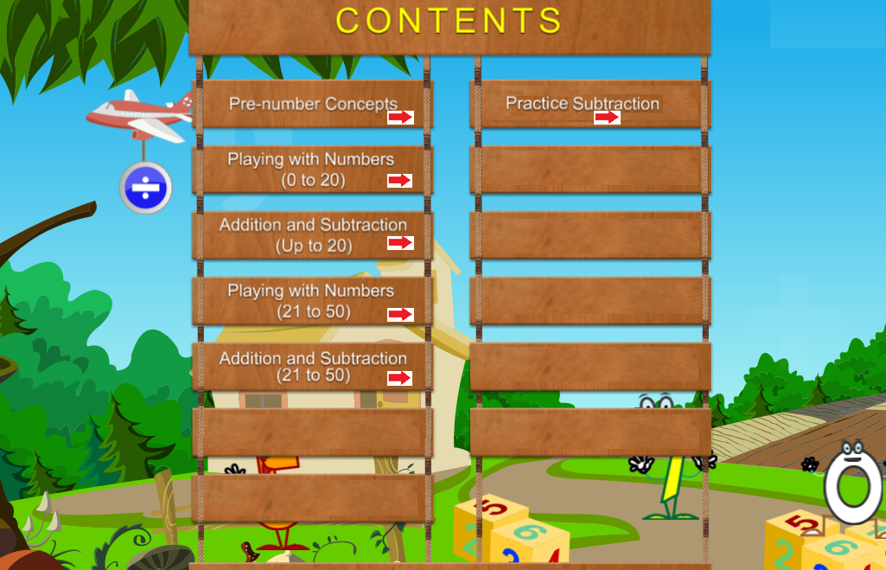

The main page has the following components:-

* Pre-number Concepts: - The basics lessons of number comparison which teaches as well as tests the child’s knowledge levels.

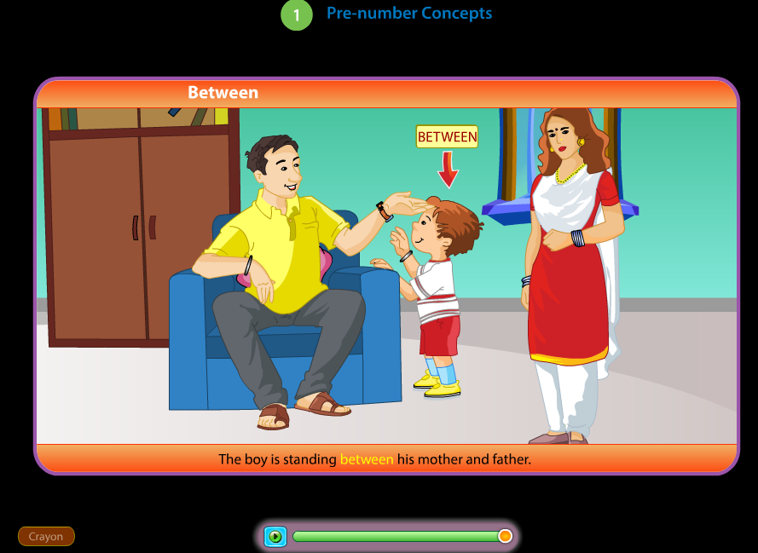

* 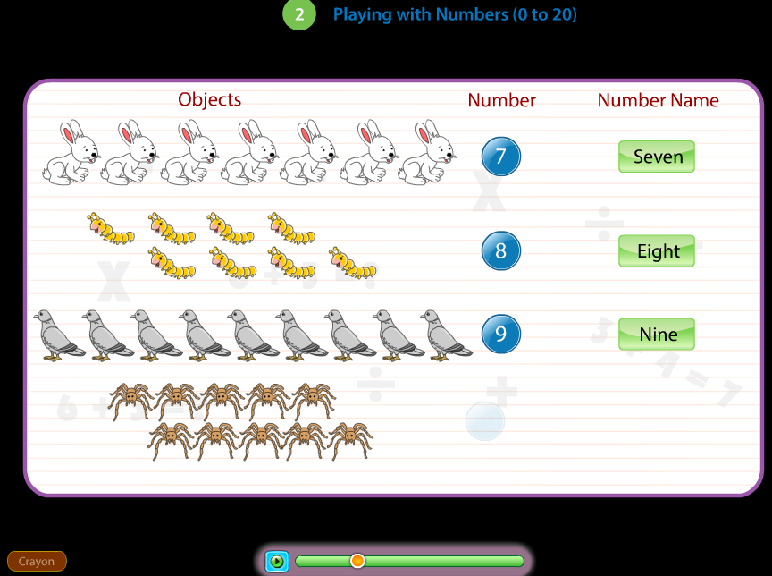Playing with Numbers: - This lesson contains teaching the child counting within an interactive environment.

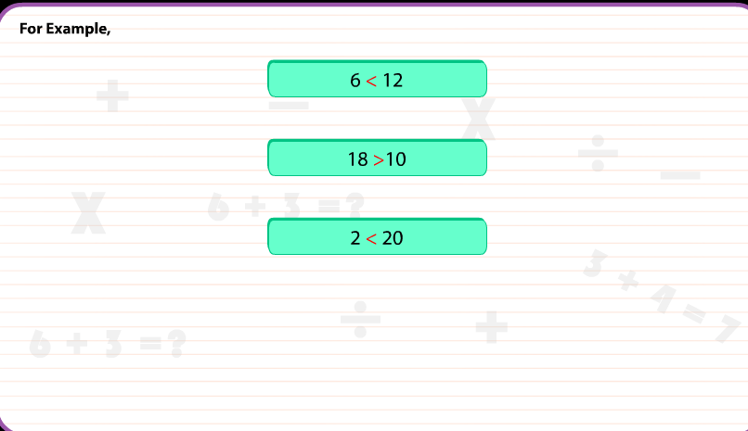

* 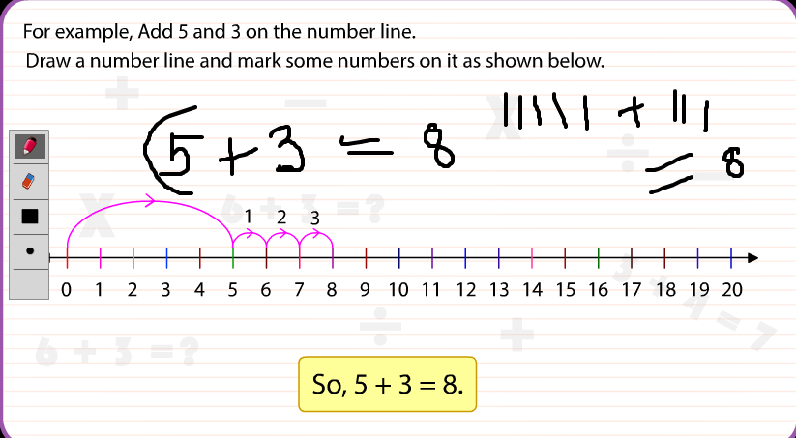Addition and Subtraction: - This lesson teaches the child basic addition and subtraction using place values as well as tests the subtraction level using short interactive exercises. I have also given a feature of crayon using which the child can simultaneous write on the laptop which increases his interaction with the intelligent agent.

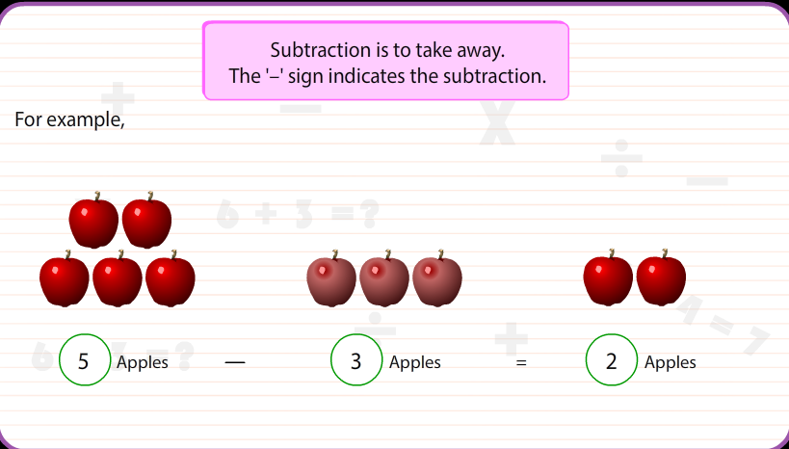

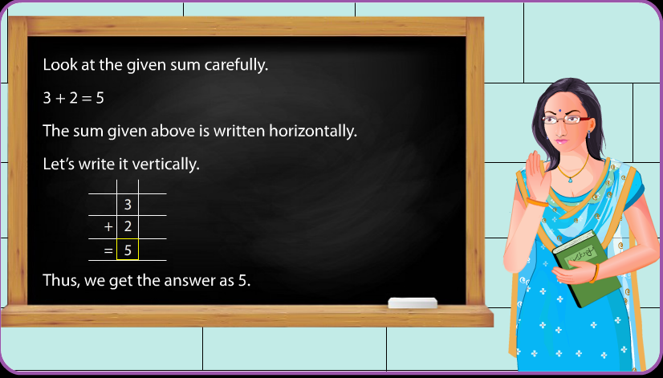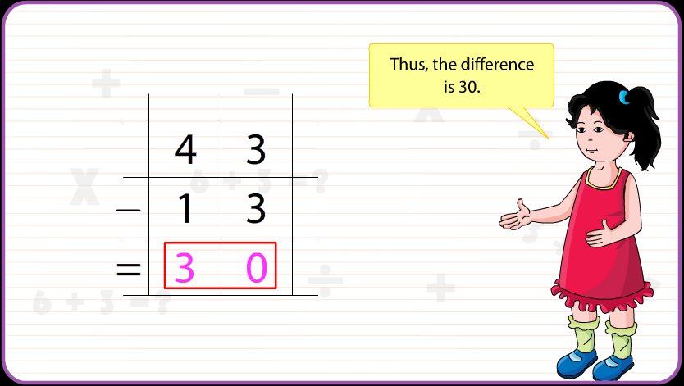

* Practice Subtraction (Exercise): - This is the practice exercise which is the final evaluation of the child. I have given it the form of a game which will take input from the child till he gets the answer right. It simultaneously counts the right and wrong answers given by the child. It has two levels which further have two choices. According to the difficulty level and his/her performance he/she is provided proper feedback of which lessons 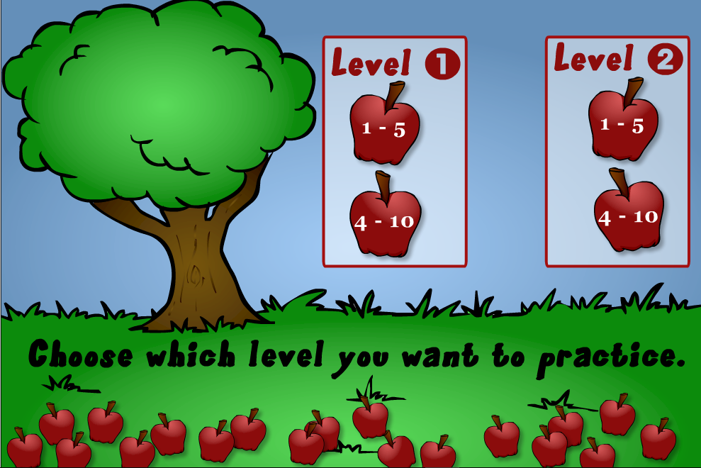should be revised and what is his/her final score.

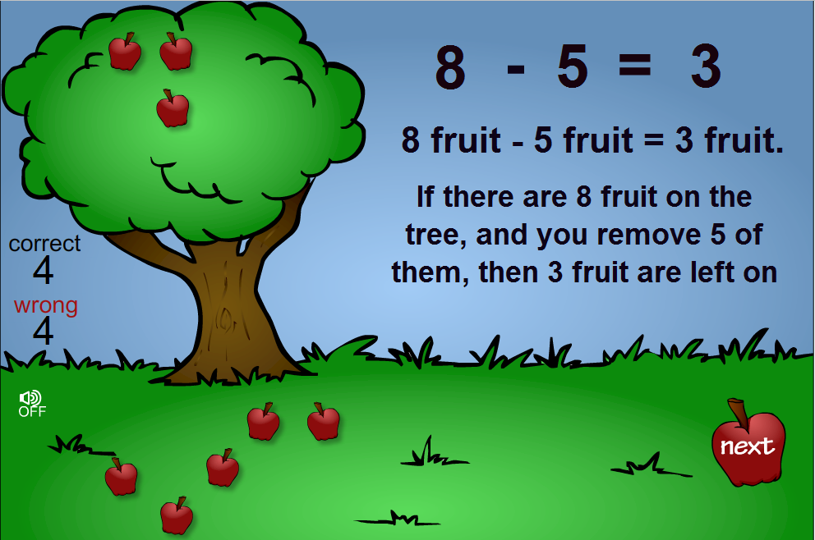

**TECHNOLOGIES USED**

**1) SOFTWARE USED: -** MICROSOFT VISUAL STUDIO, MICROSOFT SQL SERVER, MACROMEDIA FLASH PLAYER, SOFT THINK DECOMPILER AND EDITOR.

**2) FRONT END: -** HTML, CSS, FLASH (.swf,.fla)

**3) BACK END: -** MICROSOFT SQL SERVER.

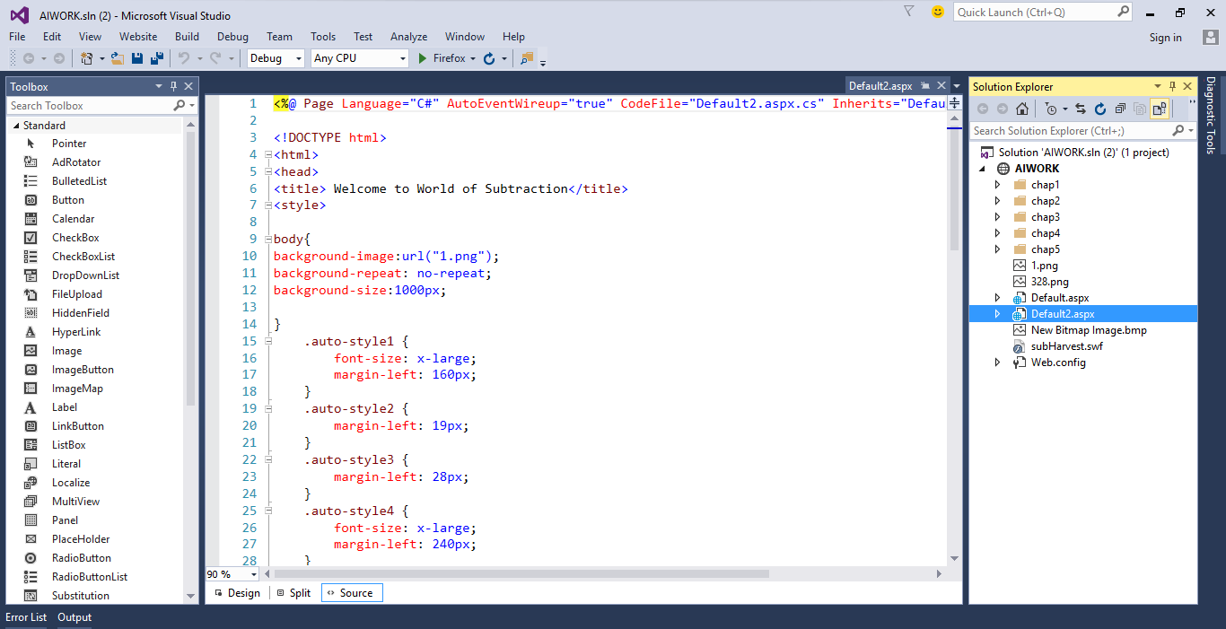

**CONCLUSION**

An agent is anything that can perceive its environment through sensors and acts upon that environment through effectors. I would like to conclude that the agent I have made to teach a student subtraction has sufficient and necessary features to teach a child subtraction beginning from the basic concepts. It contains good features to involve the student into the lessons and make them more interactive. Although I believe the project holds great future scope. We can add voice recognition and accordingly get answers from the agent in the future prototypes. We can also include Natural Language Processing but there is still a lot of future scope in NLP to make it intelligent so that the agent understands the most naïve comments of the child and replies accordingly. I hope that my agent can be put into use even after greater refining. Hence, I would like to conclude that there is great scope in the subject of Artificial Intelligence in the future and these features can be implemented in my project which will help it to reach another level.